BIT 3208: ADVANCED WEB DESIGN AND DEVELOPMENT

TOPIC: ADVANCED WEB DESIGN AND DEVELOPMENT
COURSE: BACHELOR OF SCIENCE IN COMPUTER SCIENCE
DEPARTMENT: COMPUTING AND INFORMATICS

Student Details
- Student Name: JOY KARANI
- Admission Number: BSCCS/2024/54303
- Course/Class: COMPUTER SCIENCE SEPTEMBER 2024
- Unit Code: BIT3208
- Unit Name: Advanced Web Design and Development
- Lecturer Name: MR NYORO MICHAEL
- Semester/Academic Year : 2025/2026

Project Title: STUDENT TASKMANAGER
Selected Technologies:
Frontend: html, css, JavaScript
Backend: php, mysql
Development: xampp, phpMyAdmin
Design: Canva
Version control: Github
Online Portfolio / GitHub Link: https://github.com/Joy3Nafula/bit3208-advanced-web-design

Table of Contents
Student Details 1
Project Title: STUDENT TASKMANAGER 1
Week 1: Installation and Testing of Local Development Environment 9
Week 2: User Interface Planning and System Design 12
Week 3: Front-end Interaction and Back-end Foundations 18
Week 4: Introduction to dynamic backend processing and real user interaction systems 20
Week 5: Database Components and CRUD Operations 27
Week 6: Database Intergration and CRUD operations 31
Week 7: User authentication and session management 35
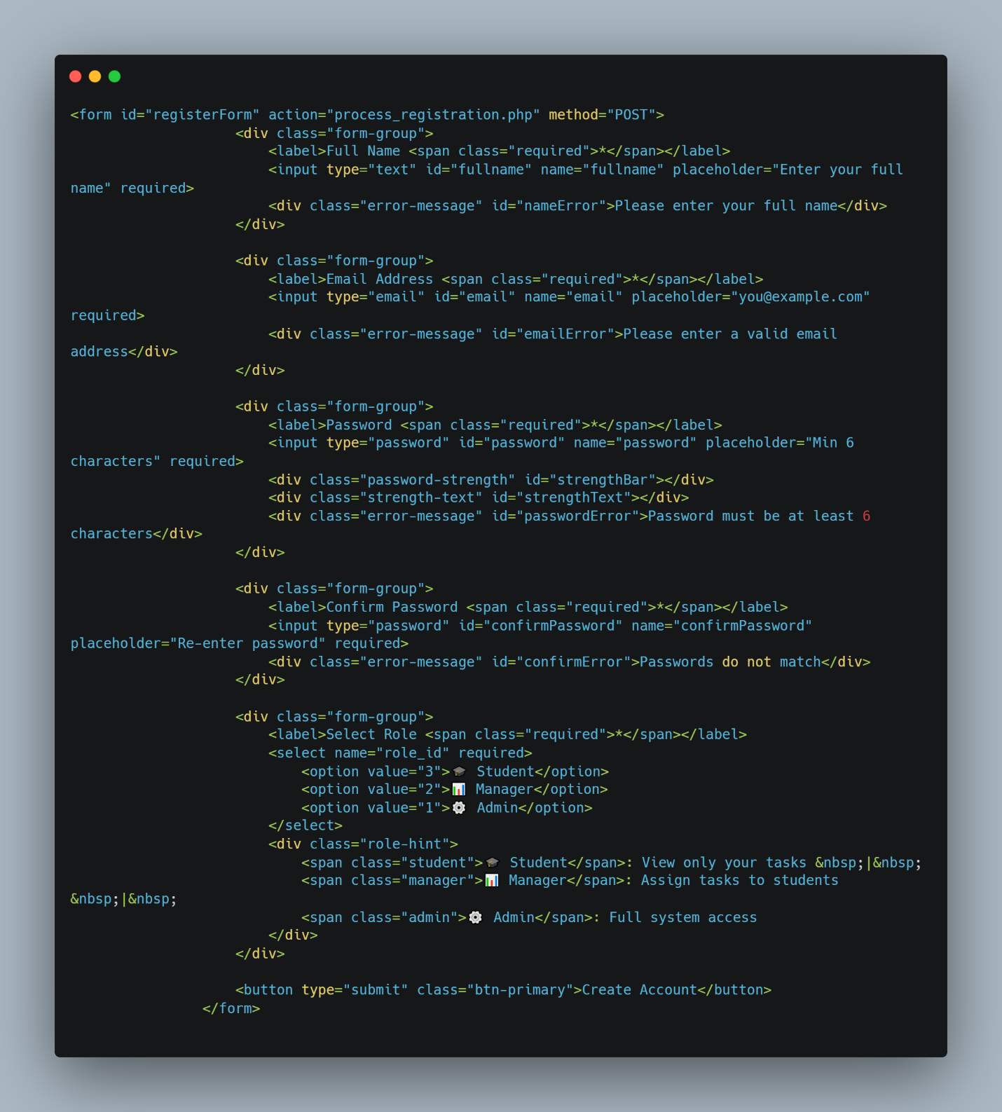 36
Saving users to a database: 36
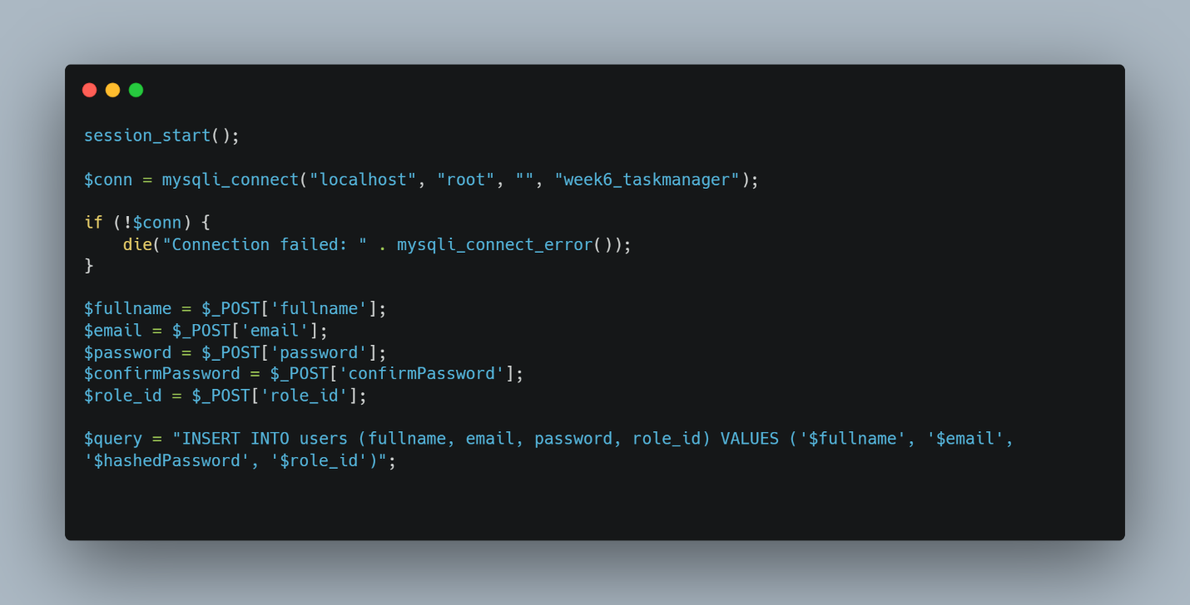 37
Hashing passwords: 37
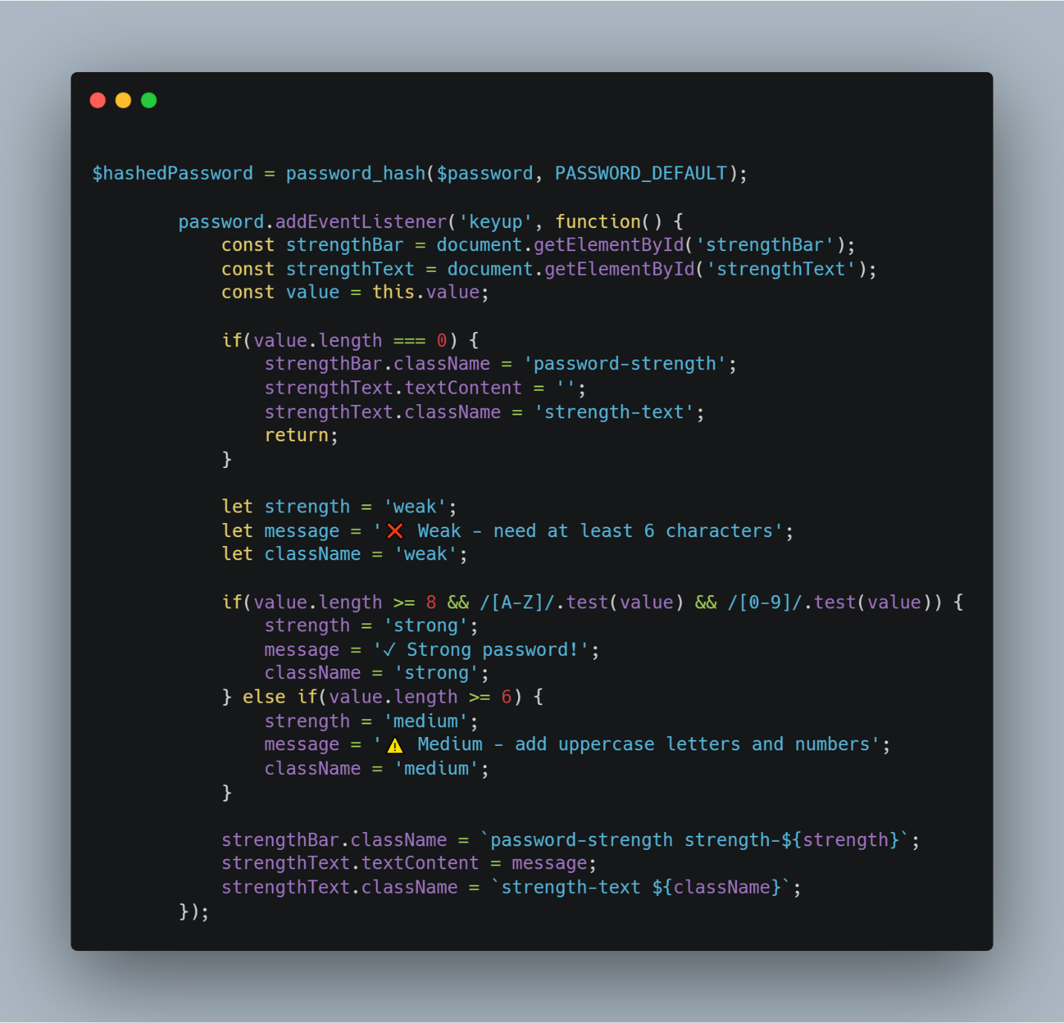 38
Validate user login credentials and create sessions: 38
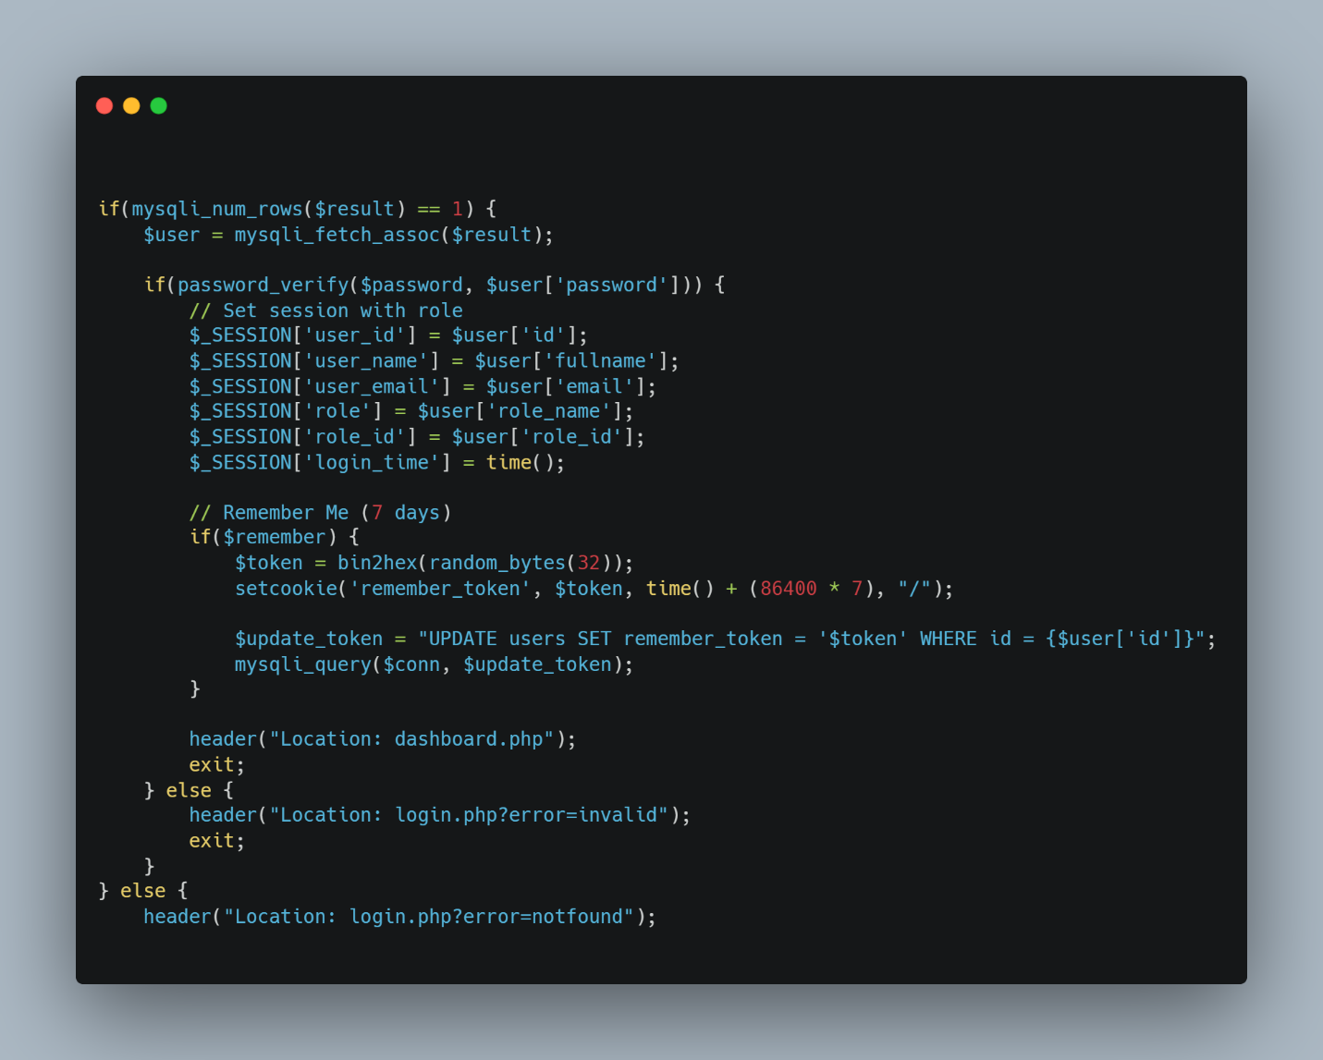 39
Role Based Access: 39
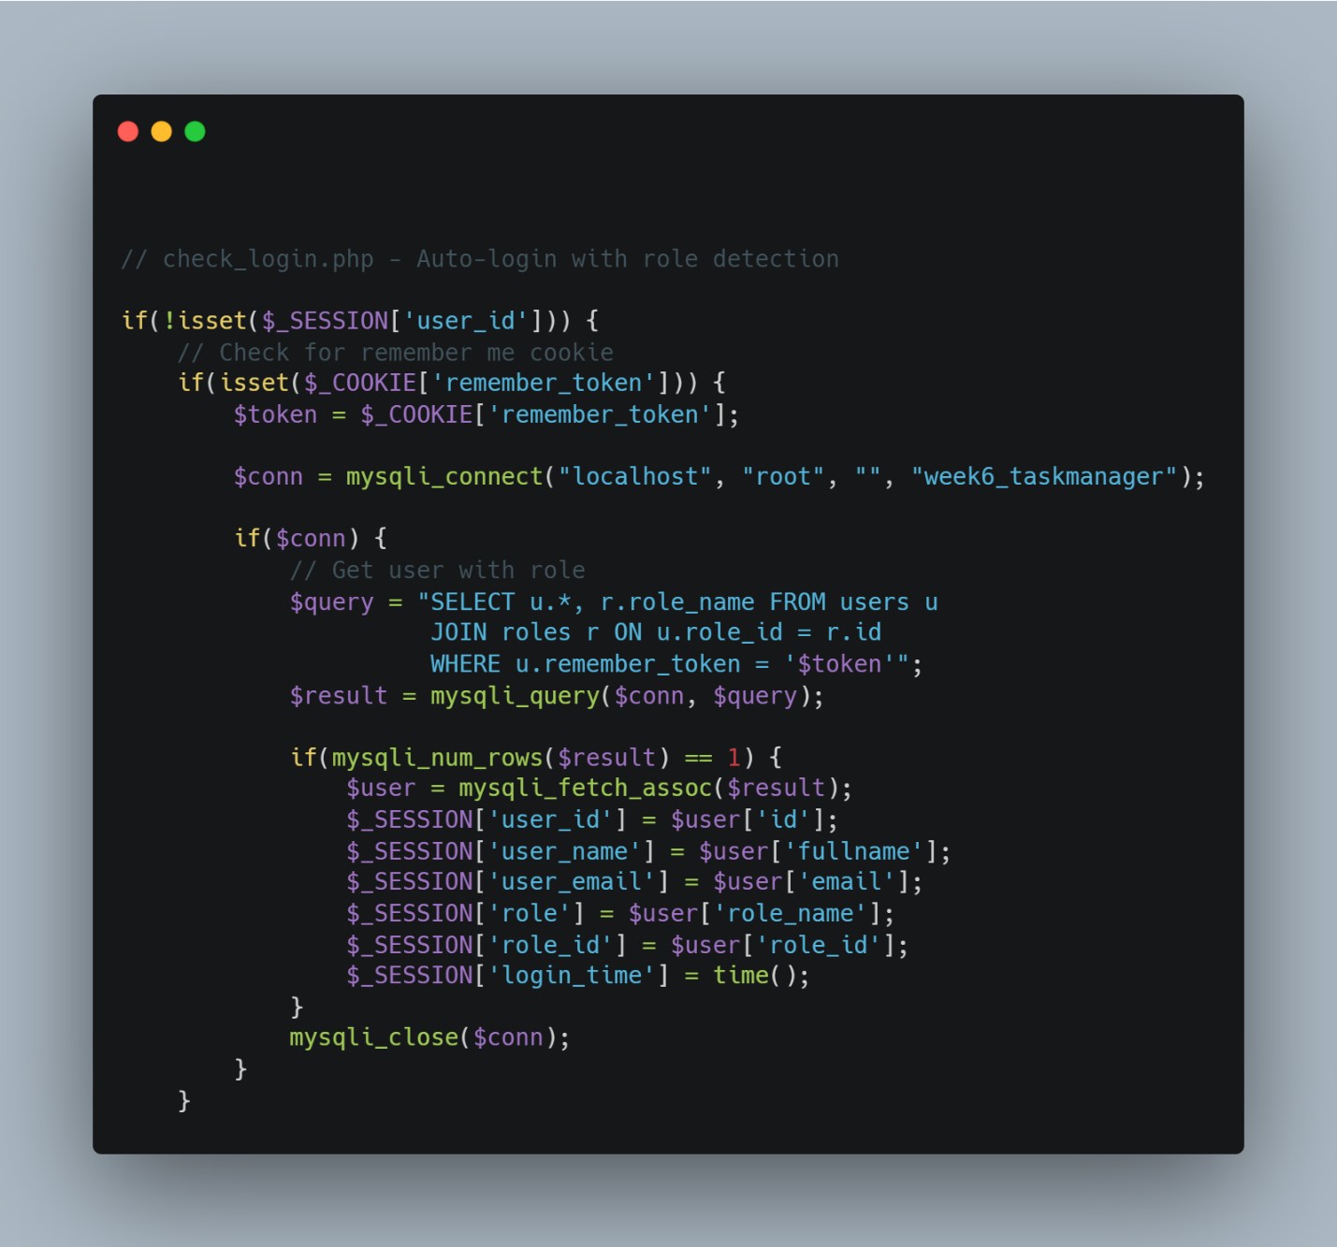 40
Display logged in user info: 40
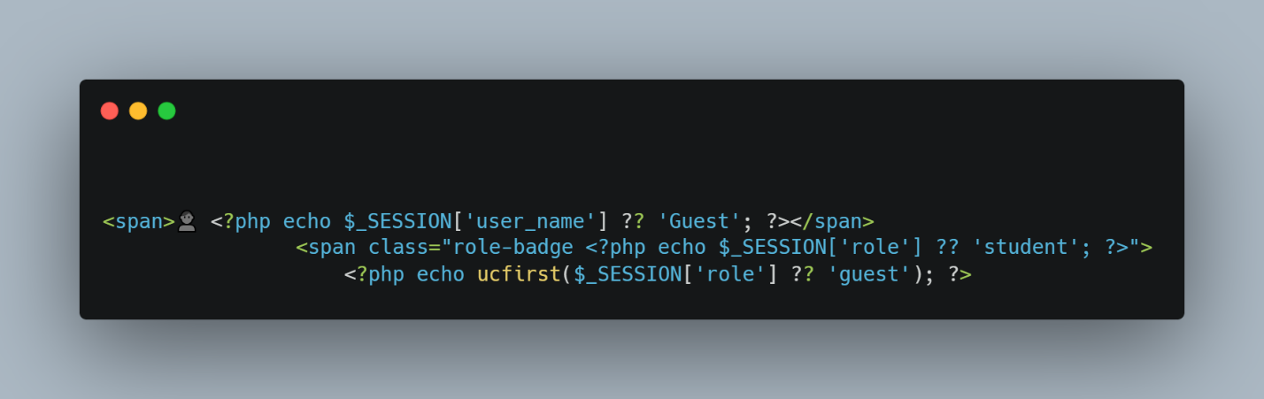 41
Destroy sessions for logout functionality: 41
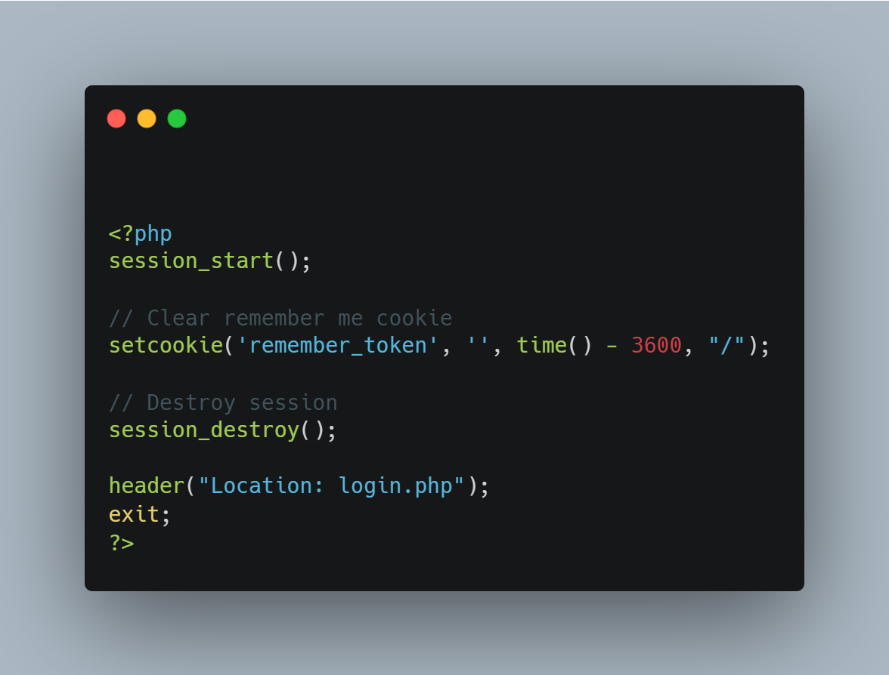 41
Week 7 reflection: 41
Authentication system complete. Registration hashes passwords with password_hash(). Login validates credentials using password_verify() and creates sessions. Dashboard protected by check_login.php redirecting unauthenticated users. Logout destroys sessions and clears cookies. All features working. 42

Week 1: Installation and Testing of Local Development Environment
Evidence:
Figure 1: Apache and MySQL Running: XAMPP Control Panel demonstrating active, conflict-free initialization of Apache (Port 80/443) and MySQL (Port 3306) background services
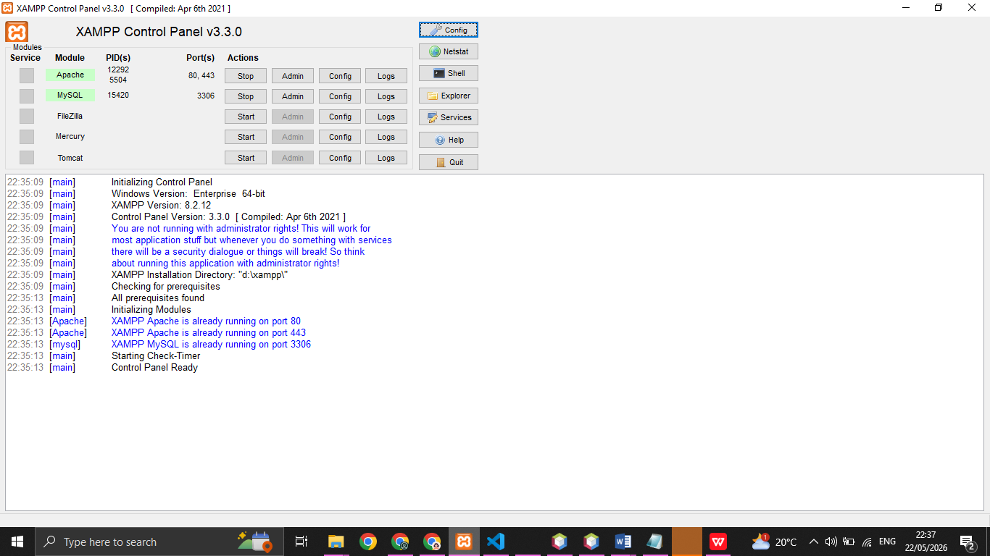

Figure 2: Localhost Test Page: Localhost dashboard confirming Apache web server is operational and serving files from htdocs directory.
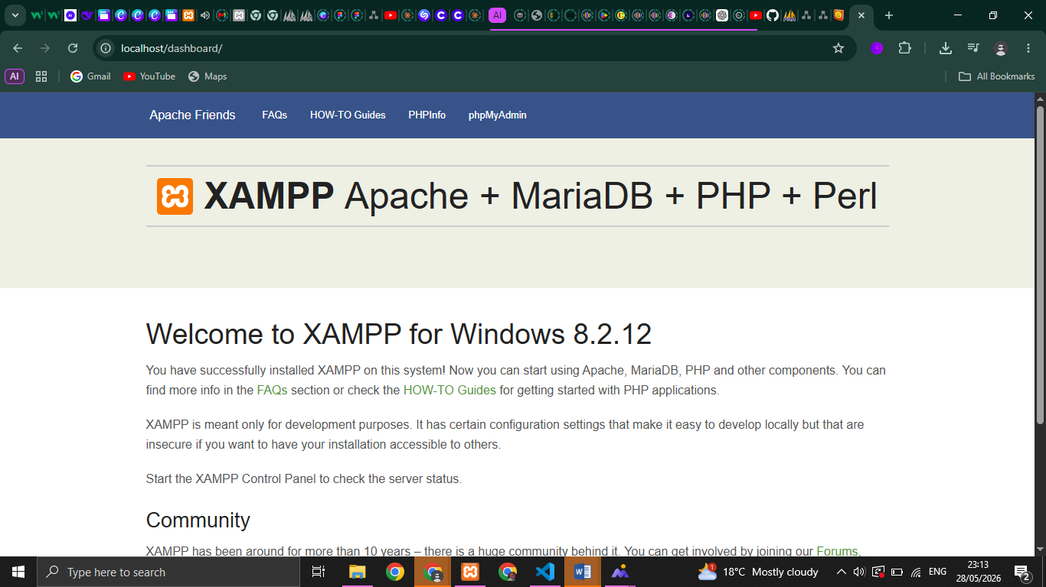

Figure 3: Hello World Test: Web browser rendering the index.php homepage from the local project directory, validating that the Apache preprocessor is actively interpreting server-side code.
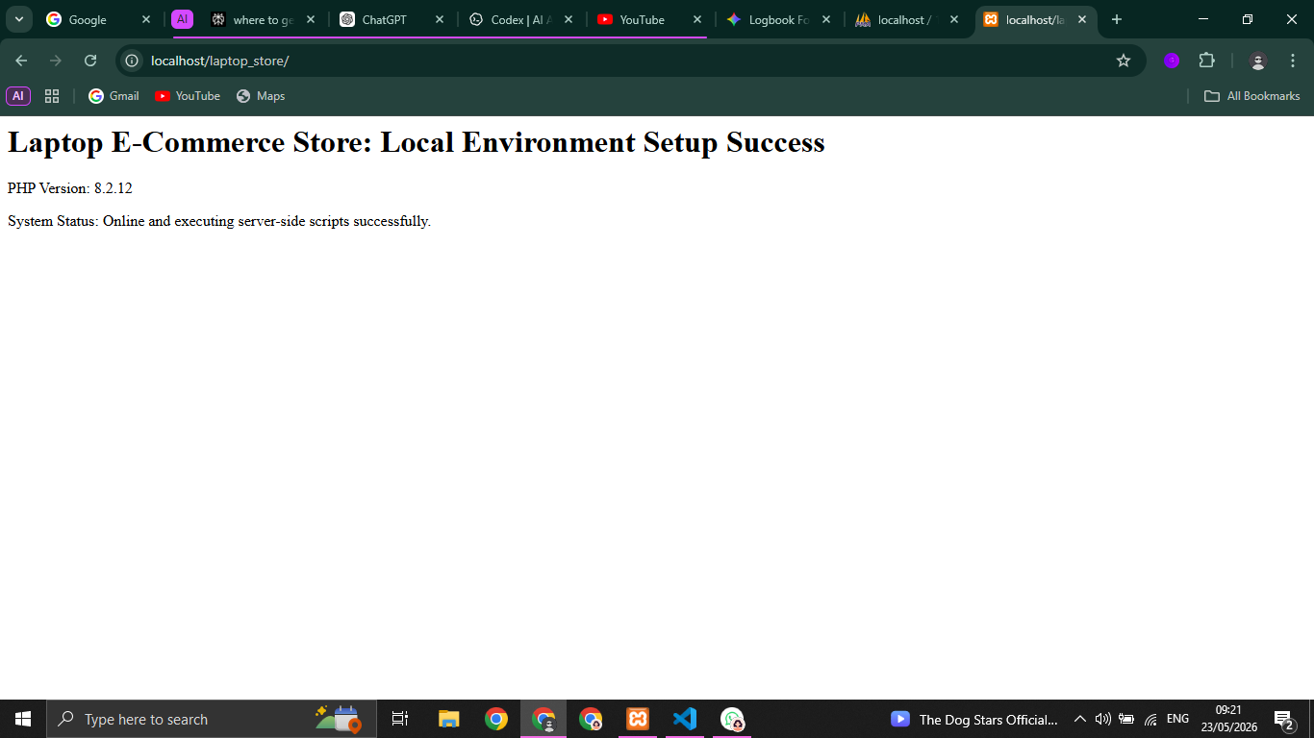

Figure 4: Database Connection Test: Execution of test_db.php demonstrating successful backend integration and communication between the PHP preprocessor and the MySQL database engine via mysqli_connect().
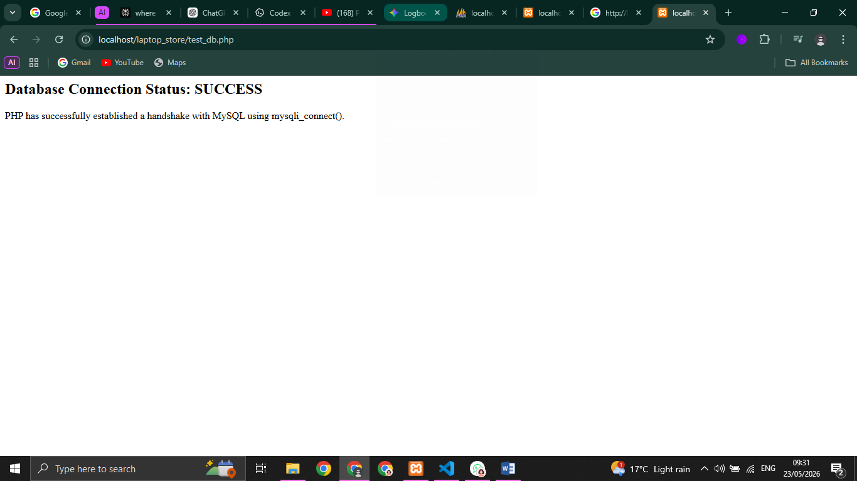
Reflection:
This week, I set up a local development environment using XAMPP, integrating Apache and MySQL. Figures 1 through 3 demonstrate the installation and verification of server accessibility via the localhost dashboard. Figures 4 proves that the PHP preprocessor executes server-side scripts and successfully communicates with the database using mysqli_connect().
A primary challenge was a storage space shortage on my host machine. I resolved this by pivoting to a cloud-based version control workflow, uploading files directly via the GitHub web interface to maintain consistent development progress

Week 2: User Interface Planning and System Design
Covering GUI basics.

Figure 5: Hand drawn wireframe for login page
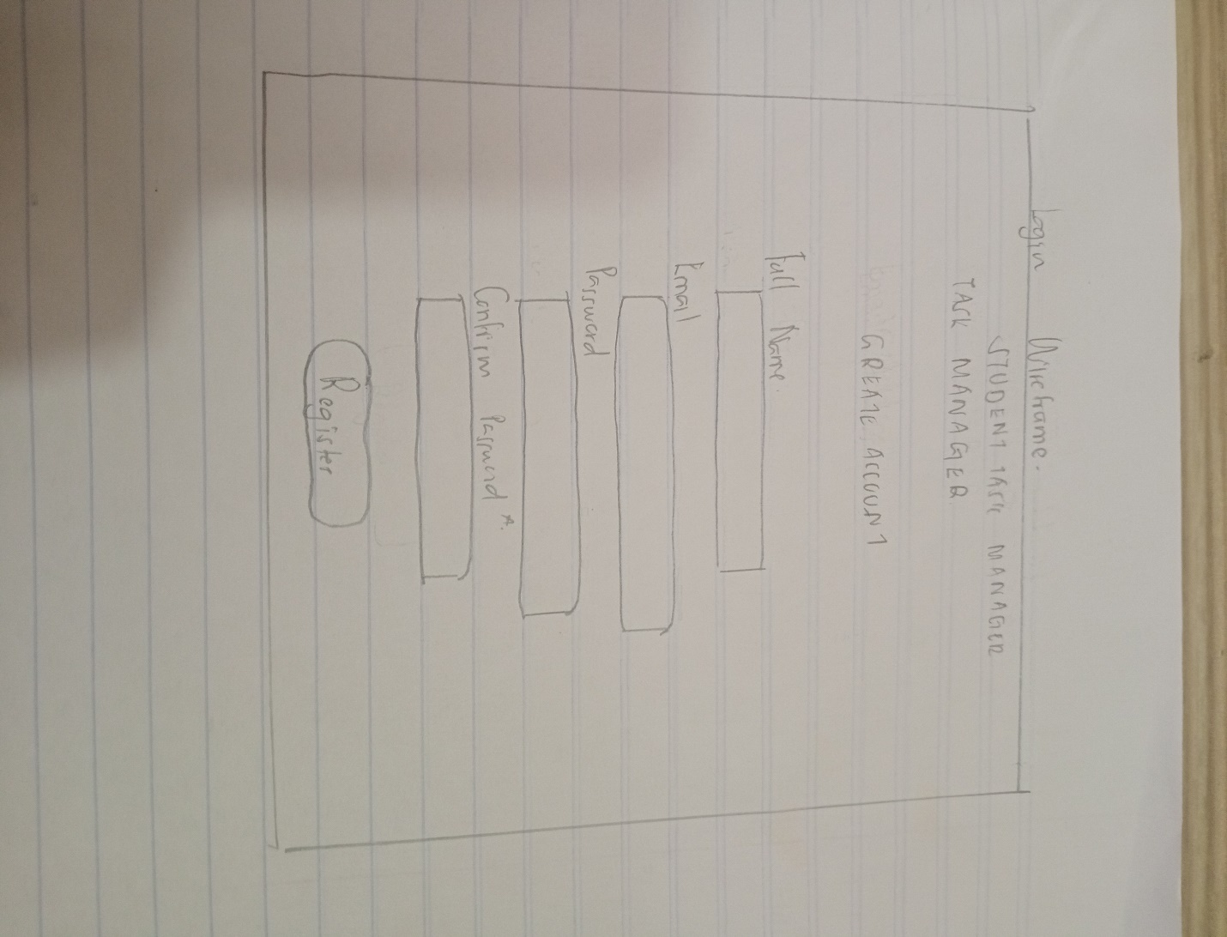
Figure 6 Dashboard prototype for Students Task Manager website drawn using canva
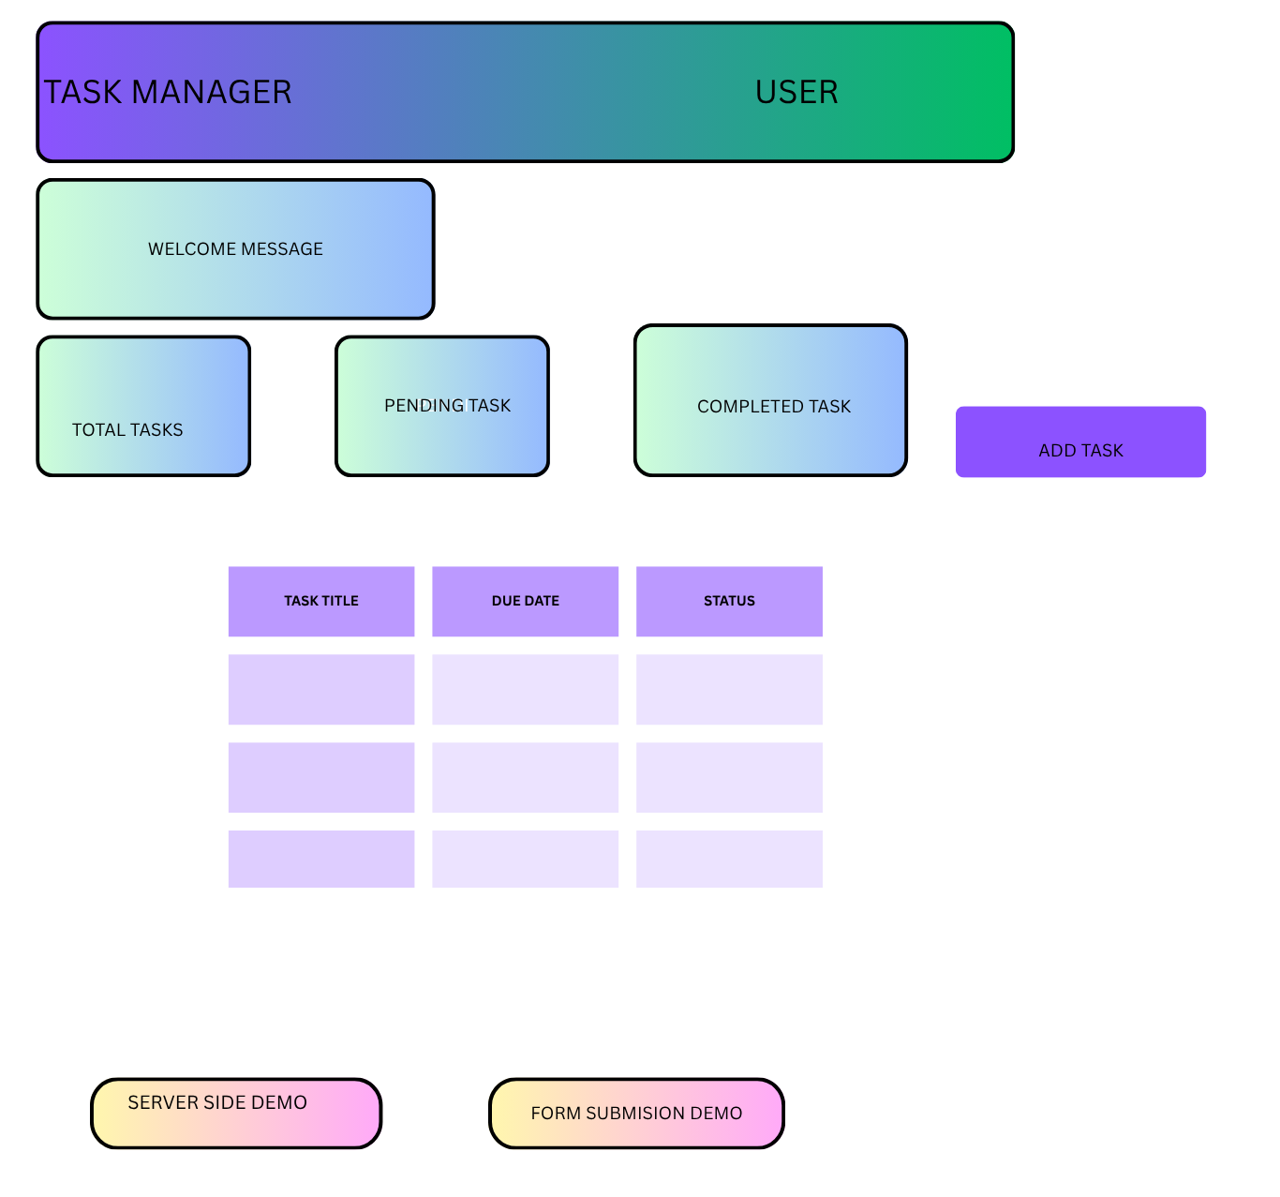
Figure 7 Mobile view mockup using standard iPhone frame
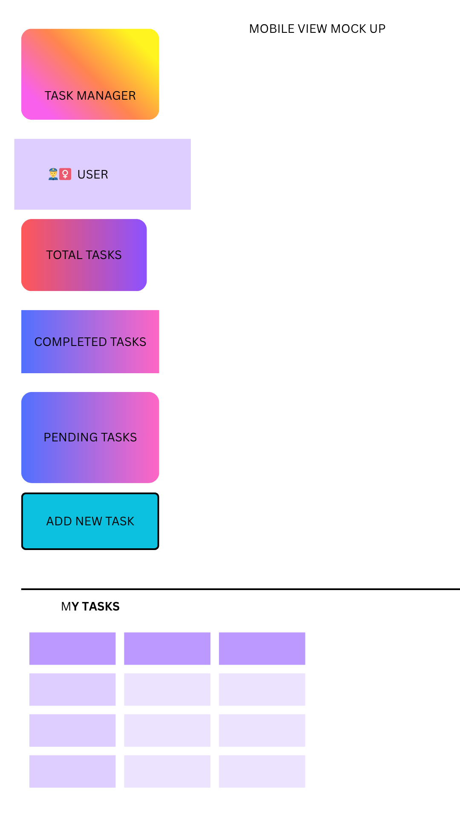
Figure 8 Flowchart navigation structure showing how users will access the system
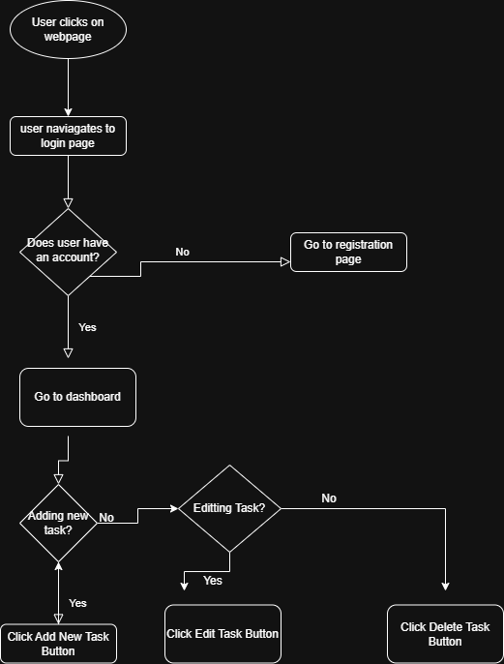

Reflection
. The purple gradient design was selected for its professional appearance and visual appeal. User experience considerations focused on minimizing clicks - the Add Task button is always visible and tasks have inline Edit/Delete icons. Color-coded status badges (green for completed, orange for pending) allow users to quickly identify task progress without reading text. Navigation flow separates public routes (login, register) from authenticated routes (dashboard, profile, tasks). Intended users are students managing coursework deadlines and professionals tracking work assignments. The responsive design adapts to mobile devices using CSS media queries, ensuring the system works on smartphones and tablets.

Week 3: Front-end Interaction and Back-end Foundations
Evidence:
Figure 9: JavaScript Form Validation: Login Form with JavaScript validation preventing empty email or password submission before data reaches the server.
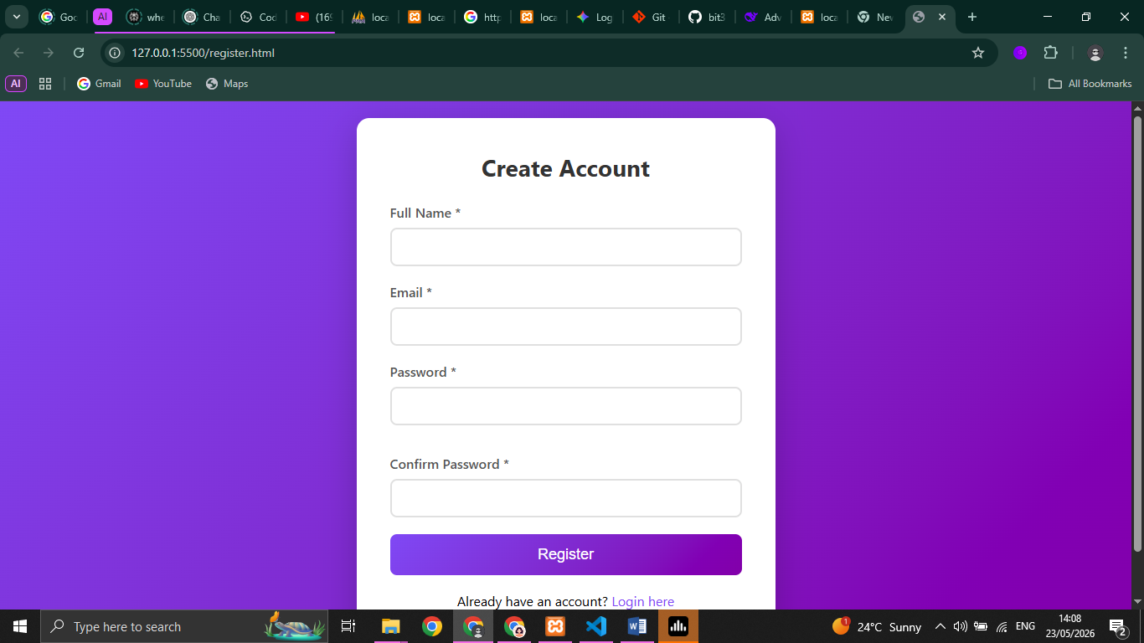
Figure 10: Password Strength Checker: The password rejects use of weak passwords such as plain letters.
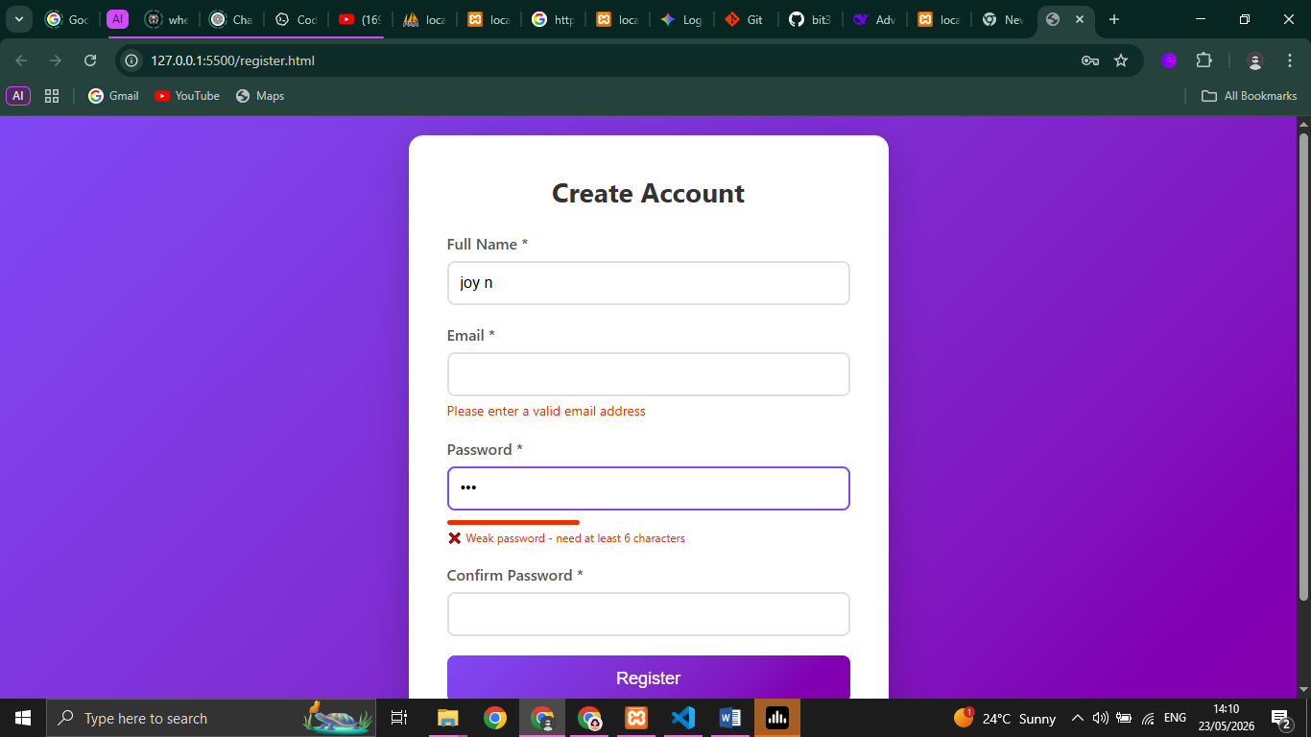
Figure 11: Database Connection Script: Database connection script demonstrating successful back-end integration between php and mysql, showing server info and database status.
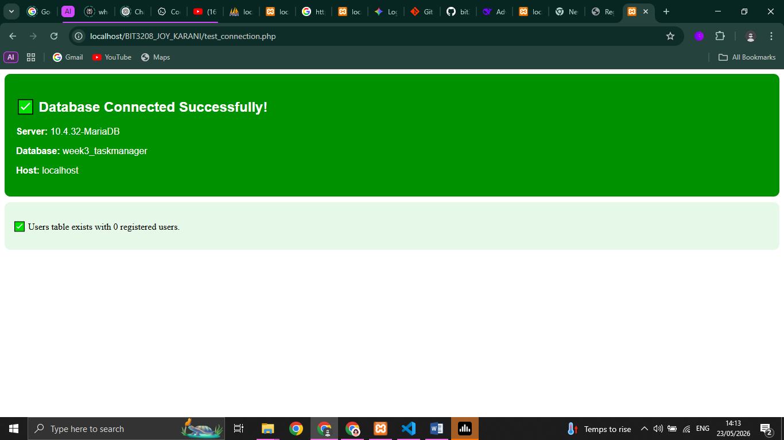
Figure 12: Dynamic User Input Handling: Dynamic user input handling in registration form demonstrating real-time JavaScript validation


Reflection:
This week I built a functional Task Management System demonstrating frontend-backend interaction. Front-end (HTML/JavaScript) collects user input and performs real-time validation including password strength checking and email format verification, preventing invalid submissions before reaching the server. Back-end (PHP) processes form data using $_POST, hashes passwords with password_hash() for security, and stores credentials in MySQL database via mysqli_connect(). Database connection matters because it enables persistent data storage across sessions. Technologies used: HTML5, CSS3, JavaScript (frontend validation), PHP 8.x (server-side processing), MySQL (database), and XAMPP (local server). The login flow shows successful frontend validation preventing empty fields, then backend authentication using password_verify() to grant dashboard access.

Week 4: Introduction to dynamic backend processing and real user interaction systems

Week 4 Deliverables
✅ Login form screenshots
Figure 13: Login Form: login form with fields for students task manager

✅ Form validation screenshots
Figure 14: view of how form validation is achieved using different technologies

✅ PHP processing screenshots
Figure 15: php working on the backend
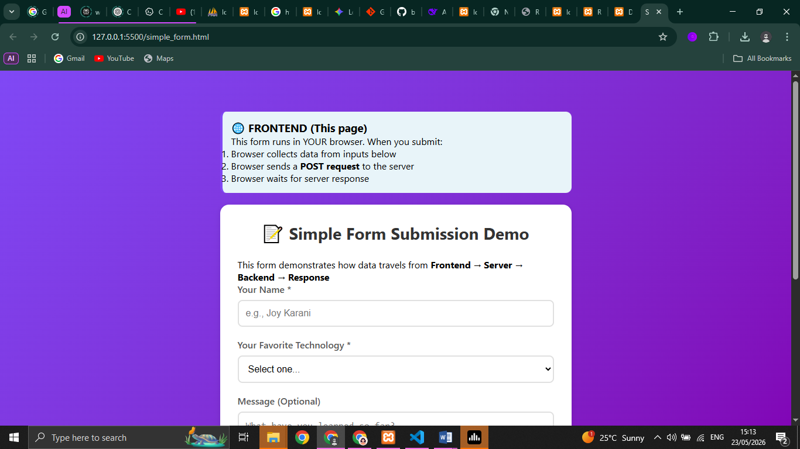
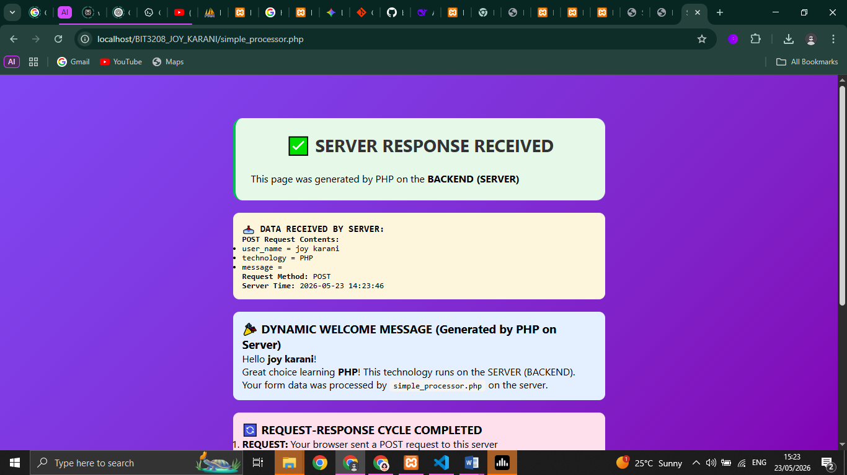

✅ Folder structure screenshots
Figure 16: Folder Structure for the project in vs code IDE
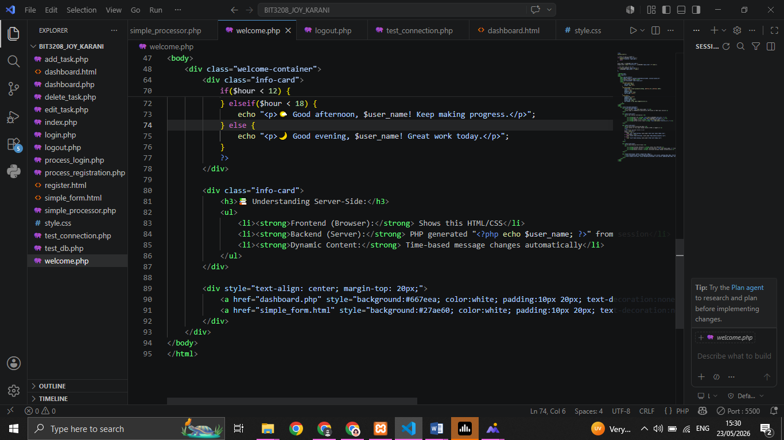
✅ Database connection screenshots
Figure 17 Evidence of successful database connection, showing database status and server name

✅ Code snippets
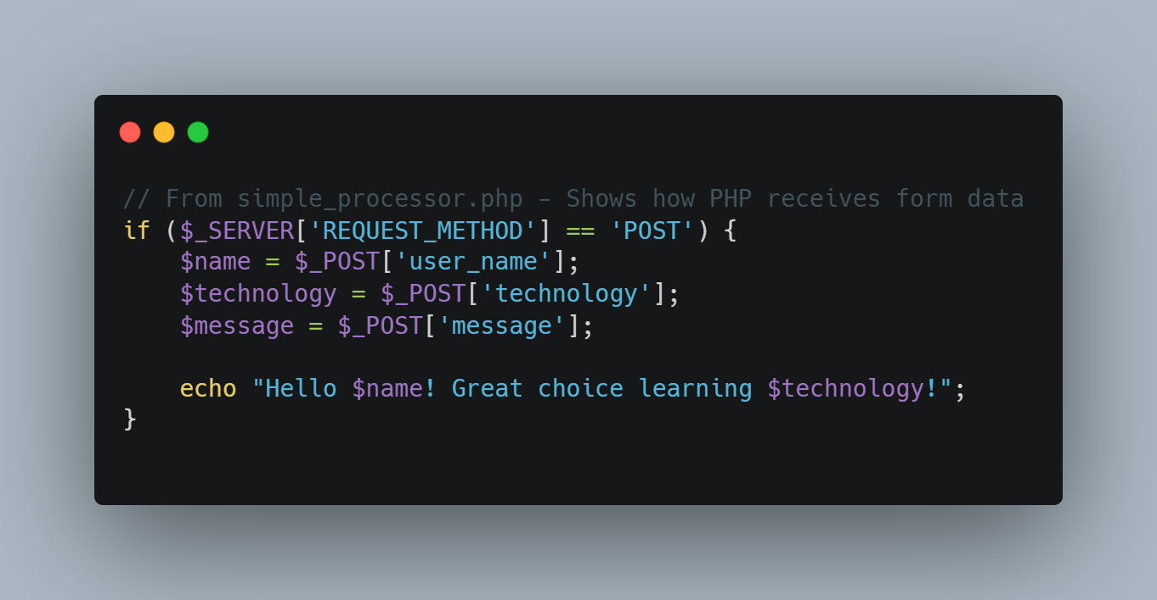

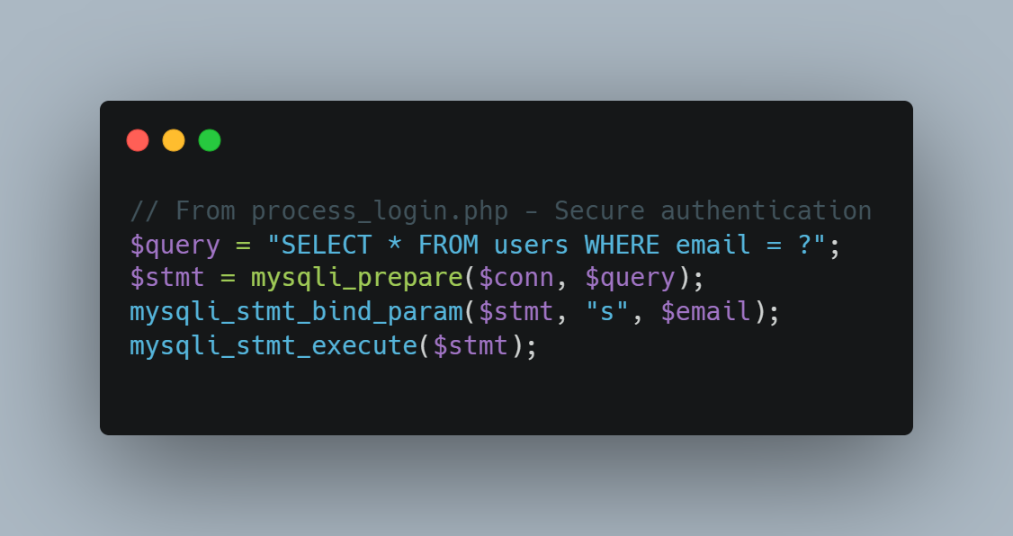
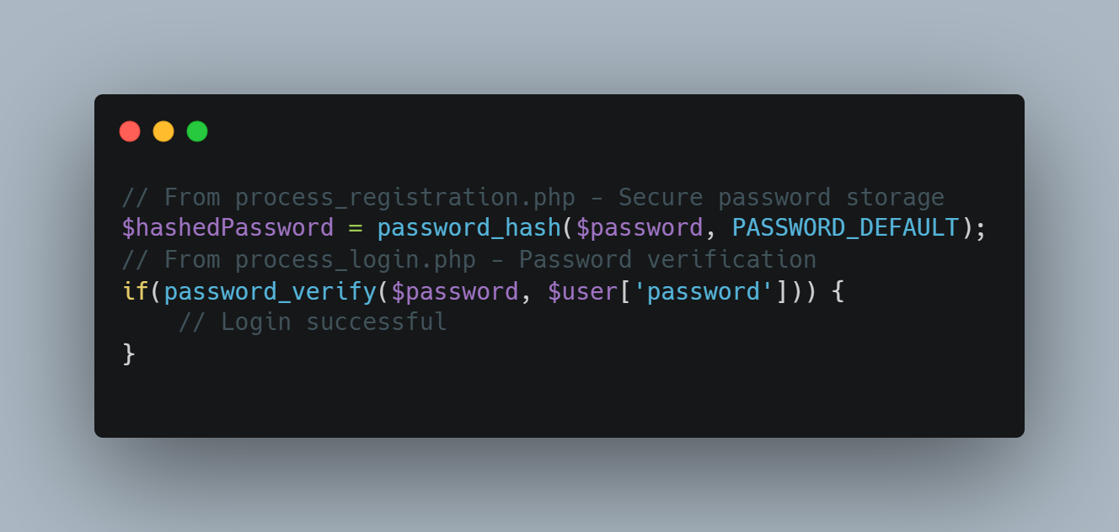
Reflection:
This week I learned backend processing where PHP handles form data via $_POST after browser sends a POST request. The request-response flow starts when a user submits a login form, server validates credentials, then returns a response (success or error). Login logic uses password_verify() against stored hashes. Sessions with $_SESSION maintain user state across pages, while the "Remember Me" feature uses 7-day cookies. Technologies: PHP, MySQL, sessions, cookies, and password hashing.

Week 5: Database Components and CRUD Operations

Week 5 Deliverables
✅ Database screenshots
Figure 18 Active database records of Tasks Table in Task Manager Database
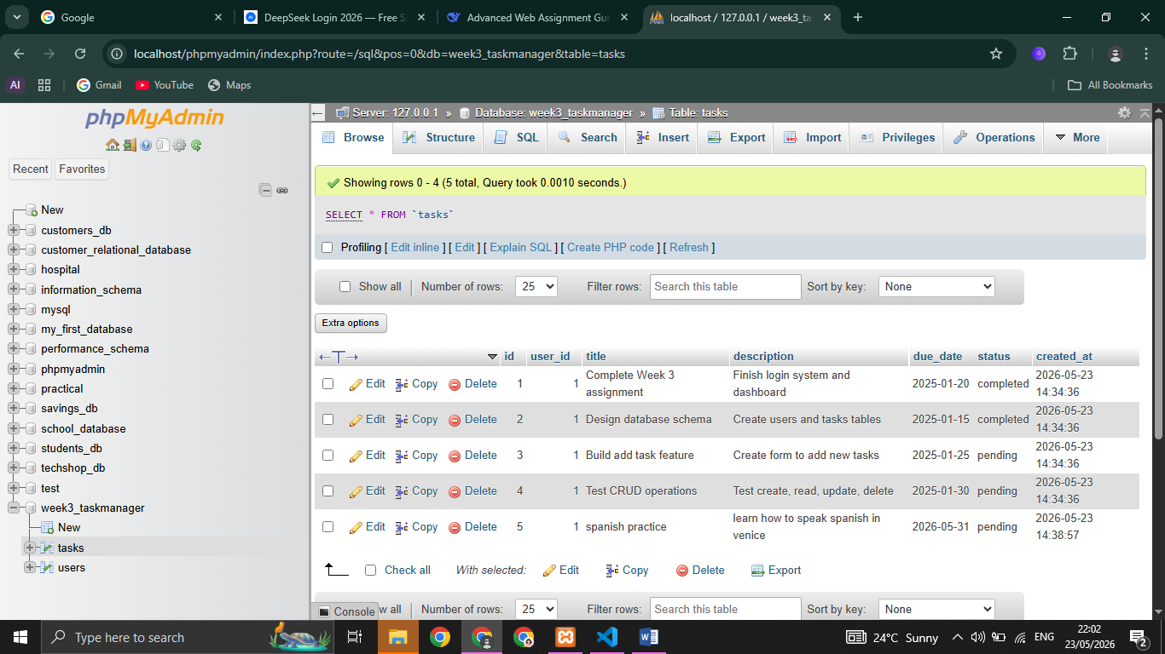
✅ Table creation screenshots
Figure 19 sql syntax for creating Users table
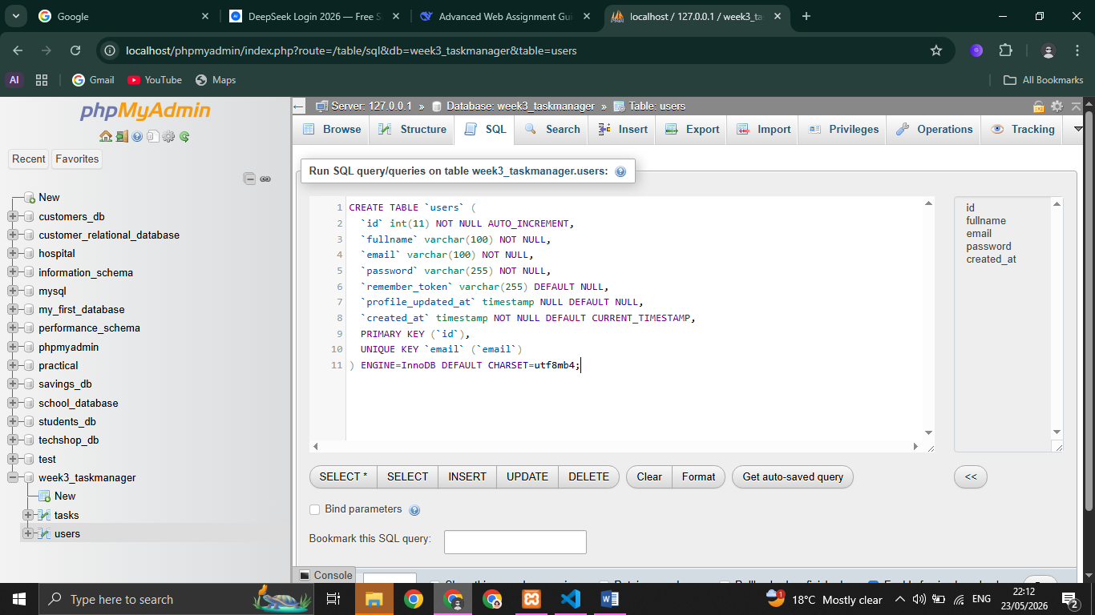
Figure 20 sql syntax for creating Tasks table
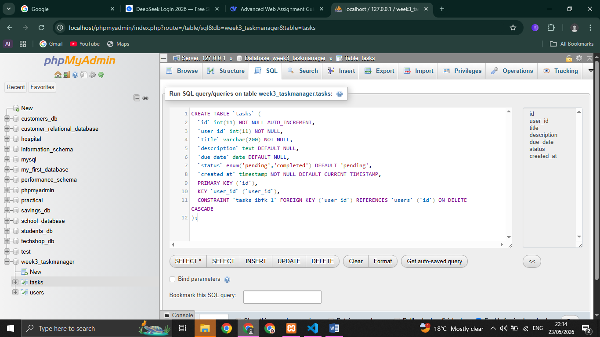
✅ CRUD operation screenshots
Figure 21 sql syntax and statements for basic CRUD operations in MySQL
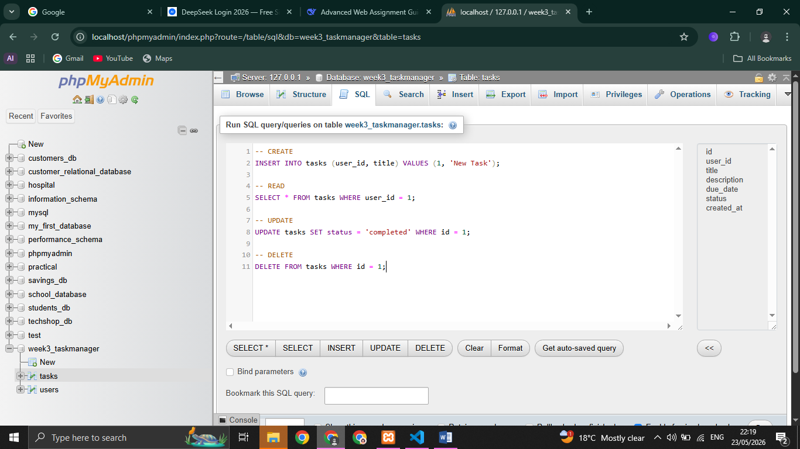
✅ Login database integration screenshots

✅ SQL query screenshots
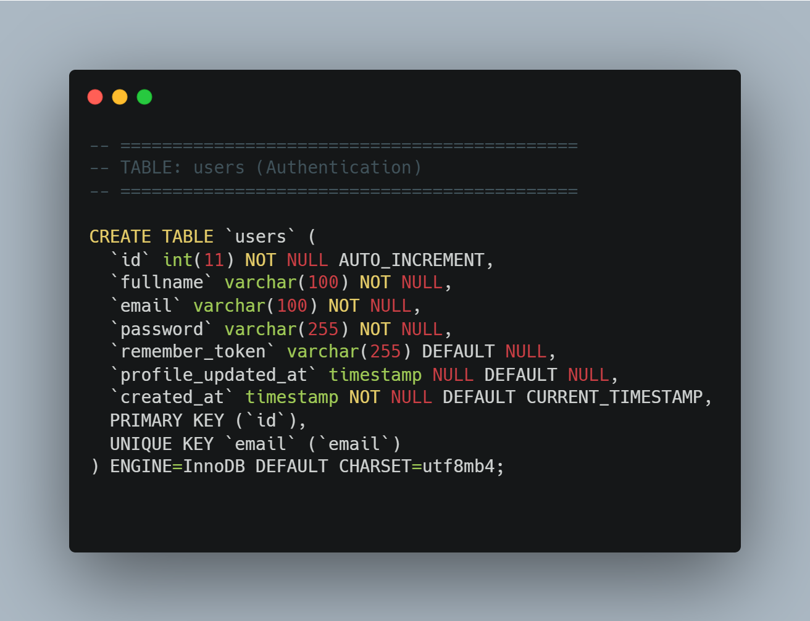
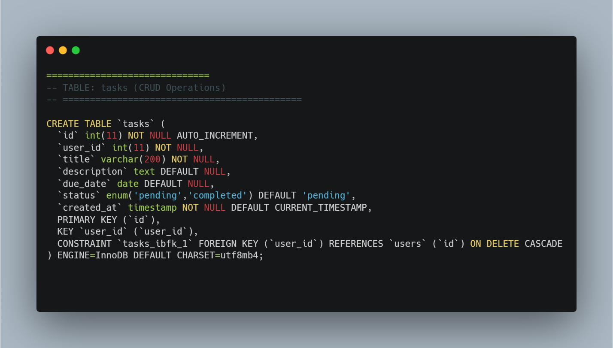

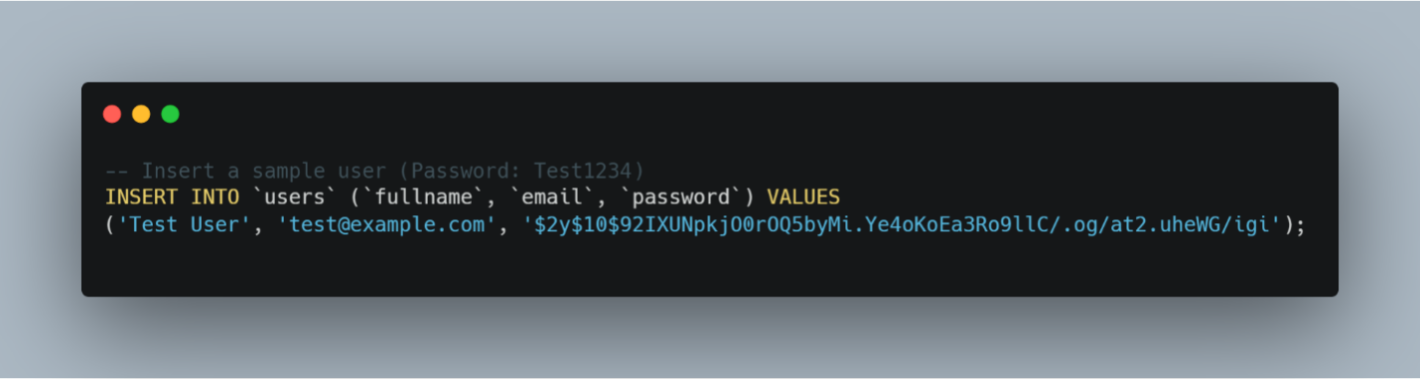
Figure 22 sql query showing how to insert values into Tasks table, after successful update on user’s page
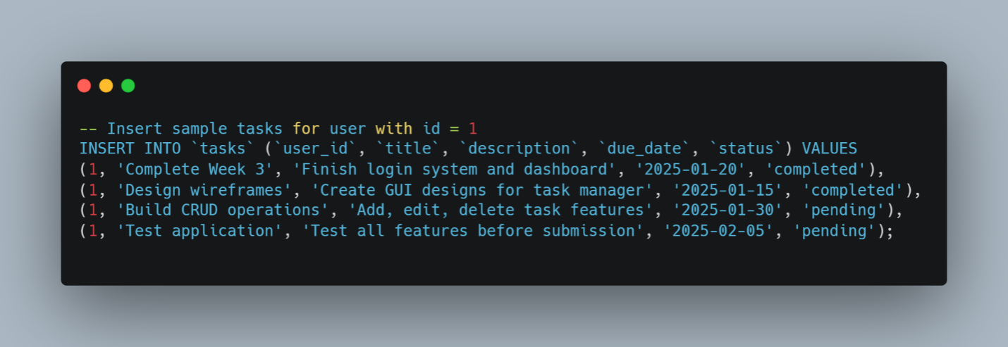

Reflection:
Week 5 focused on database integration for my Task Management System. The database consists of two tables: users for authentication and tasks for CRUD operations. The users table stores id, fullname, email, hashed password, and created_at timestamp. The tasks table stores id, user_id (foreign key linking to users), title, description, due_date, status, and created_at. This one-to-many relationship ensures data isolation - users only see their own tasks. CRUD operations are implemented via add_task.php (Create), dashboard.php (Read), edit_task.php (Update), and delete_task.php (Delete). All database connections use mysqli_connect() with proper error handling.

Week 6: Database Intergration and CRUD operations
Creating a database:

Php database connection:

Figure 23 image showing successful mysql databse connection
Registration Form:
Figure 24 figure shows addition of tasks into Task database through sql statements
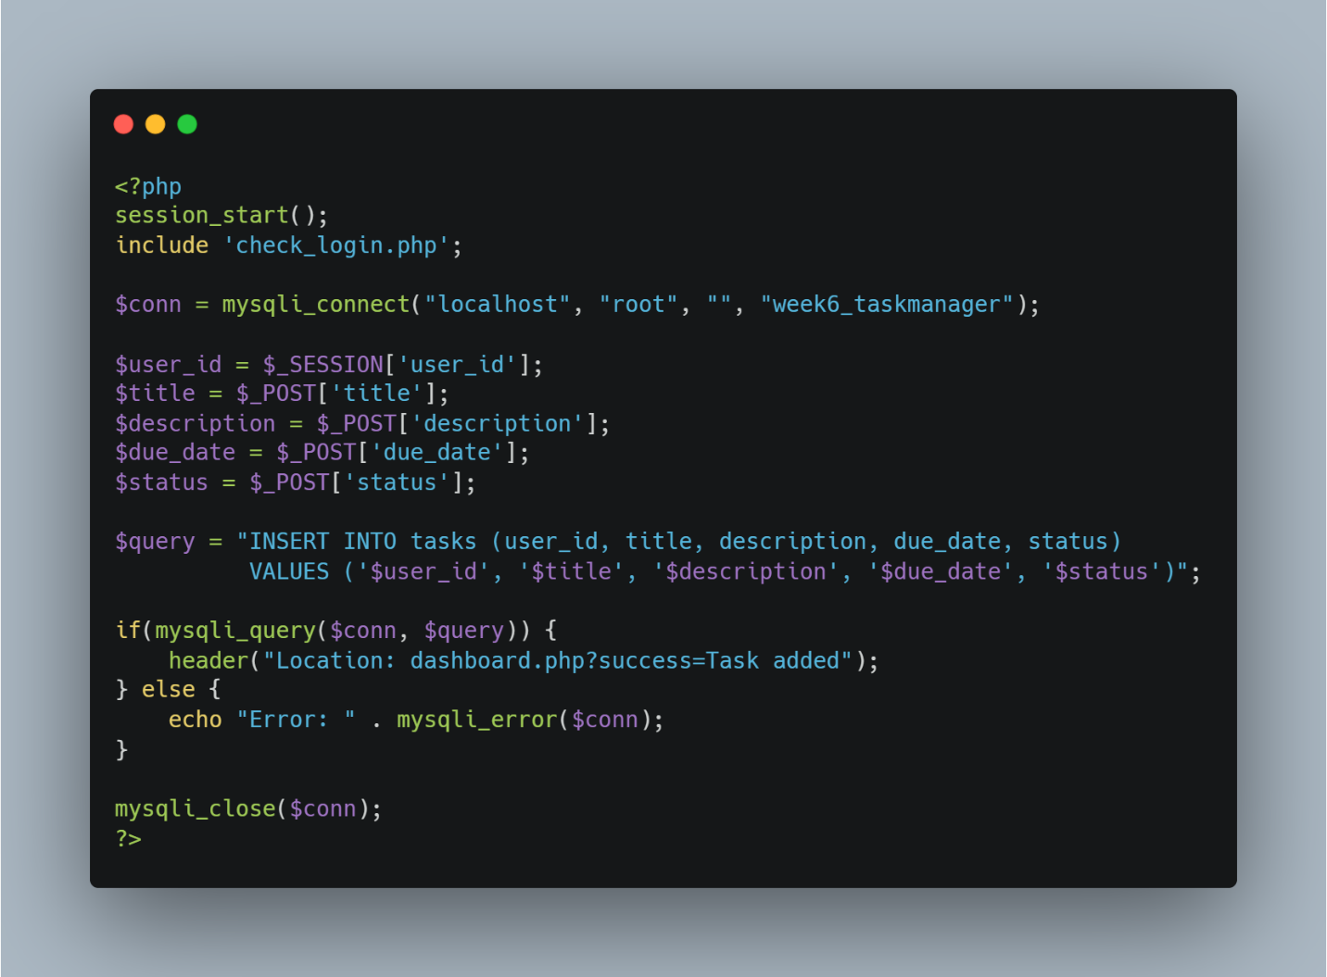
Display Records:
Figure 25 image of the records as stored in tasks database
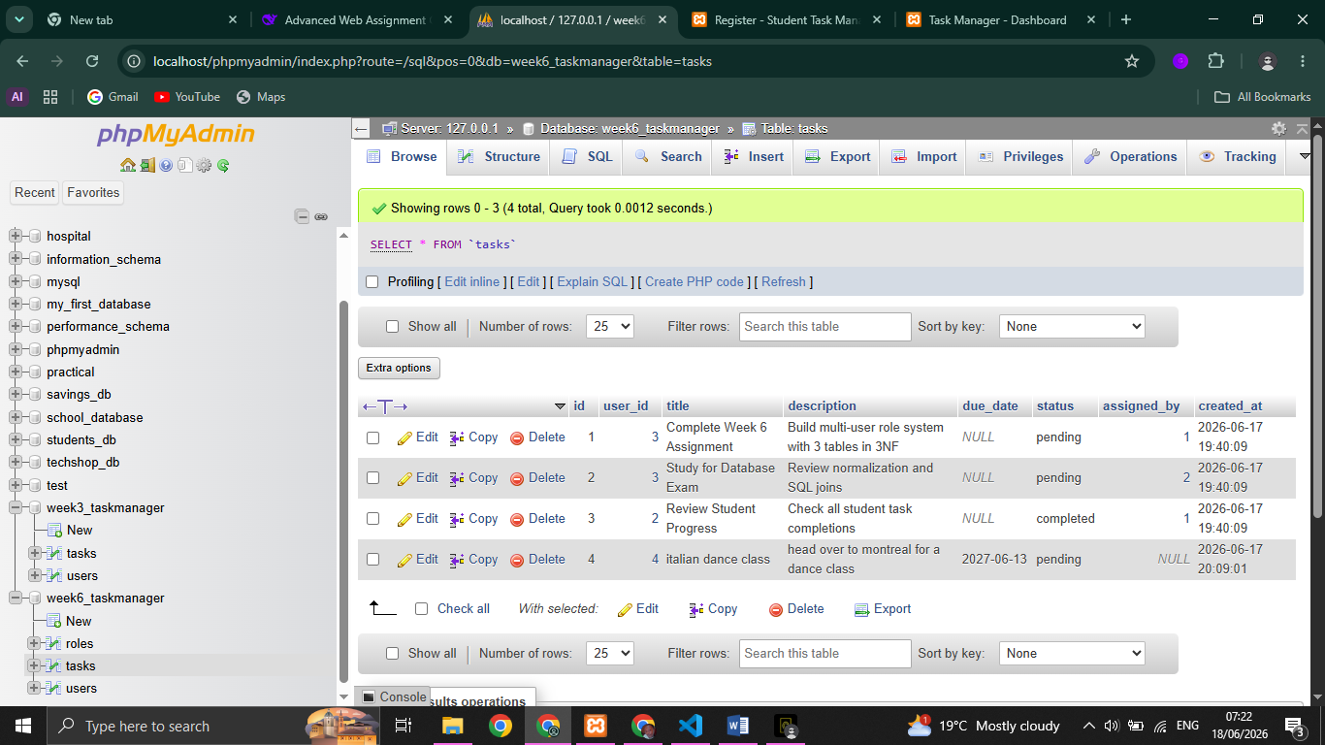

Update and delete records:
Figure 26 crud operations through update operations
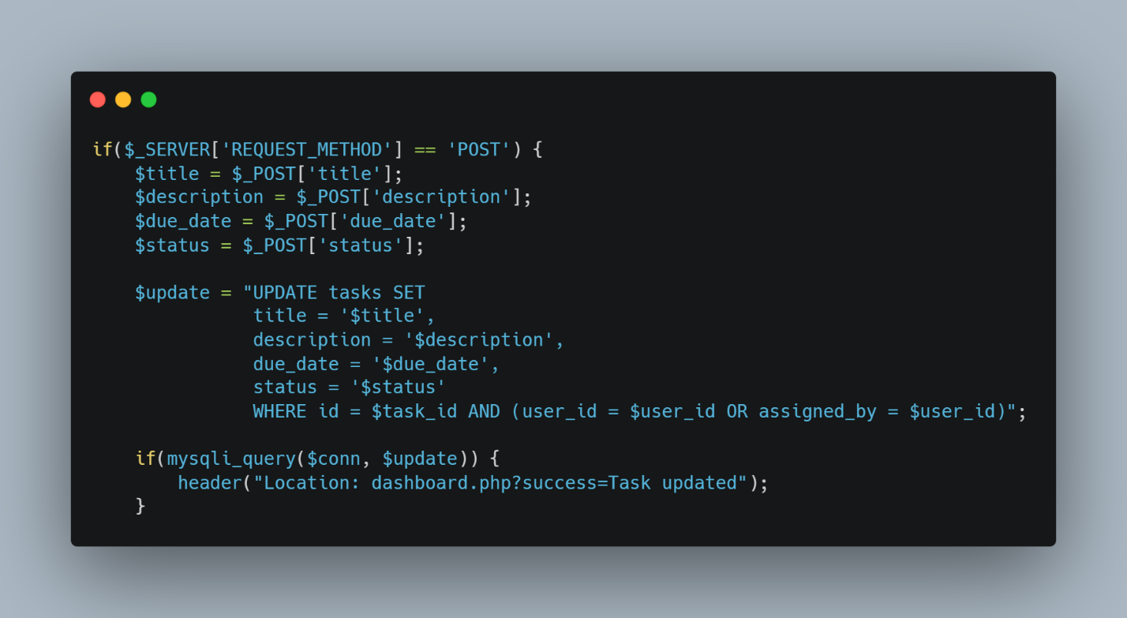
Week 6 Reflection:
Built multi-user role system with 3 tables in 3NF. Admin manages all users/tasks, Manager assigns tasks, Students view own tasks. Sessions with 7-day cookies maintain login. Used JOIN queries to display user roles. Technologies: PHP, MySQL, sessions, cookies, RBAC.

Week 7: User authentication and session management
User Registration:
Figure 27script showing user registration form



Saving users to a database:

Figure 28 php code showing how new users are added to the database



Hashing passwords:
Figure 29 passsword hasing to ensure security and unpredictability



Validate user login credentials and create sessions:
Figure 30 session creation and validation of logged in users



Role Based Access:
Figure 31protecting dashboard by ensuring only authorized users



Display logged in user info:
Figure 32header showing information of the user currently logged in to the system



Destroy sessions for logout functionality:
Figure 33 destroying sessions upon logout



Week 7 reflection:

Authentication system complete. Registration hashes passwords with password_hash(). Login validates credentials using password_verify() and creates sessions. Dashboard protected by check_login.php redirecting unauthenticated users. Logout destroys sessions and clears cookies. All features working.

